Radish Seed Dose Response Worksheet – Teacher Key

Experiment 1: Radish Seed Dose Response

My Calculations:
Make a 50% chemical mixture
Using dilutions to make all three dilutions (50%, 25%, 12.5%)

Hint – make 40ml of your 50% chemical mixture (See Figure 1)
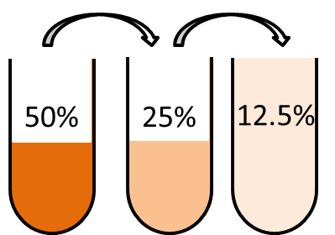
Figure 1. Since we are going down by half each time, we can use dilutions to create all three chemical mixtures.

Example: If Mary has 50ml of water, plus 50ml of vinegar and she mixes them together, she has a 50% mixture, because it is half water and half vinegar.

Calculations for the 50% chemical mixture
Add 20ml of water to 20ml of chemical and mix well.

Make a 25% chemical mixture
Example: If Mary took 50ml (one-half) from her water-vinegar solution (25ml vinegar, 25ml water), and added 50ml of more water, what would she have now?
___25__ml vinegar
___75__ml water
What is the percentage of vinegar in her solution now? 25%

Calculations for the 25% chemical mixture
Take 20ml from the 50% mixture and add 20ml of water

Make a 12.5% chemical mixture
Hint: 12.5% is half of 25%
Hint: You only need 20ml, but you will end up with 40ml
Example: If Mary took 50ml (one-half) from her new water-vinegar solution and added 50 ml of more water, what would she have now?
___12.5___ml vinegar
___87.5___ml water
What is the percentage of vinegar in her solution now? 12.5%

Calculations for the 12.5% chemical mixture
Take 20ml from the 25% mixture and add 20ml water

Radish Seed Dose Response Report Template and Assignment

Assignment: Using your results from the radish dose response experiment, write a lab report. Lab reports are a good way to show what you did, how you did it, what you saw, and what your results mean. Scientists use lab reports to show their data to other scientists. A good lab report is written very clearly, so that another scientist could read your report and then do the experiment. It’s like an instruction manual.

Your lab report should have an introduction, methods, results and discussion section. Attached is an example of a lab report for a different experiment. Use the questions and prompts below to help you write your lab report.

Introduction
[In this section, describe the purpose of the experiment and your hypothesis’]
- How does the radish dose response experiment work?
- Why did you choose the chemicals you did?
- What were your hypothesis’ and why?

Methods
[In this section, write out the methods you used, to include how you analyzed your data.]
- What materials were required for the experiment? (Sandwich bag, radish seeds, etc.)
- What calculations did you do?
- How long did the experiment last?
- How did you analyze your data and at what points in the experiment? (Do not show your data here)

Results
[In this section, you will present your data. You may have pictures and tables to show your data.]
- All data should include your controls
- Each figure and table should have a legend – a sentence or two explaining what your figure/table is showing
- Describe your data, but do not say what it means

Discussion
[In this section, you should explain what your results mean]
- Do your results suggest that any of your chemicals are toxic?
- Can you rank the three chemicals you tested in order of toxicity?
- What are other variables that could have influenced your experiment?
- Why might one chemical be more toxic than another?
- Were any of your results surprising?
- Did all chemicals show toxicity at the same dose?

**Sample Lab Report**
Name: Maria Mercury Date: April 20, 2014
Title: Yeast Dose Response Experiment Report

Introduction
The yeast dose response is a great way to measure toxicity of chemicals and chemical mixtures. Yeast cells need water and sugar to live. When they have water and sugar, yeast take oxygen and turn it into carbon dioxide, which is a gas. We can measure the amount of carbon dioxide to figure out if the yeast is healthy. A healthy yeast would produce more carbon dioxide than an unhealthy yeast. A dose response tells scientists if chemicals are toxic at certain doses.
Dose: The amount of a chemical added to the yeast. We tested three different doses with each chemical mixture.
Response: The effect the chemical has on the yeast. We measured the amount of carbon dioxide the yeast made.
We looked at three different chemicals.
- Salt – salt is used in cooking food so humans are exposed to salt
- Baking soda – baking soda is used in cooking food, but can also be used as a cleaning chemical
- Bleach – bleach is a cleaning chemical used in the bathroom and the kitchen

Hypothesis: We hypothesized that the bleach would be the most toxic, because the label on the bottle has a lot of warnings. We hypothesized the salt would be the second most toxic because too much salt can be bad for people. We didn’t think the baking soda would have any effect on the yeast.

Materials and Methods
Calculations: We calculated a low, medium and high dose for each chemical. The amounts are listed in Table 1.
Chemical mixture | Low dose | Medium dose | High Dose
Baking Soda | ¼ teaspoon | ½ teaspoon | 1 teaspoon
Bleach | ¼ teaspoon | ½ teaspoon | 1 teaspoon
Salt | ¼ teaspoon | ½ teaspoon | 1 teaspoon
Table 1. The dose for each chemical that was added to the yeast.
Yeast dose response experiment: Nine sandwich bags were laid out on a table. Each bag was labelled with the date, the chemical that would be tested and the dose (Figure 1). Each bag had 1 ½ teaspoons of yeast and 1½ teaspoons of table sugar, plus the right dose of chemical. Three control bags which only had yeast, sugar and water were prepared by the teacher. 2 tablespoons of warm water were added to each sandwich bag. Bags were sealed after the water was added and all air was squeezed from the bag. The experiment lasted for 30 minutes.
Data collection: Since all the bags are the same size, the height of the bag can be measured to get an estimate of the amount of carbon dioxide the yeast made. Using a ruler that measures centimeters, the height of the bag was measured (Figure 2). All data was recorded in a lab notebook.
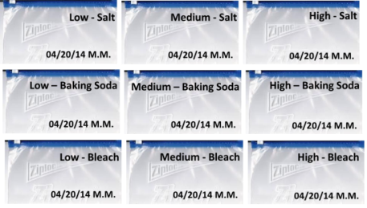
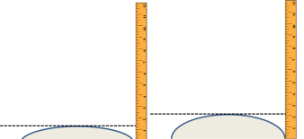

Figure 1. How the sandwich bags were labeled. Figure 2. Measuring the amount of carbon dioxide in the bags.
Results
We compared our experimental results to our teacher’s 3 control bags. To measure the amount of carbon dioxide, we measured the height of each bag. All results are summarized in Table 2.
It was interesting that the high-baking soda bag had more carbon dioxide than the control bags. The medium and high dose bleach bags had no carbon dioxide. The doses of salt seemed to make the yeast produce a little less carbon dioxide. We graphed our data to make dose-response curves (Figure 3).
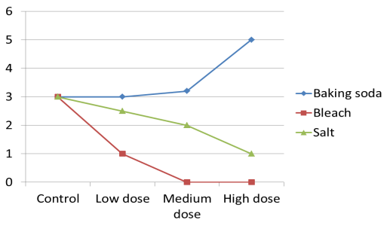
Mixture | Height | Mixture | Height
Control – 1 | 3 cm | Baking Soda – Low | 3 cm
Control – 2 | 2.7 cm | Baking Soda – Medium | 3.2 cm  Height (cm)
Control – 3 | 3.1 cm | Baking Soda – High | 5 cm
Bleach – Low | 1 cm | Salt – Low | 2.5 cm
Bleach – Low | 0 cm | Salt – Medium | 2 cm
Bleach – Low | 0 cm | Salt – High | 1 cm

Table 2. Height of each sandwich bag after 30 minutes. Figure 3. Dose response curves for each chemical.

Discussion
We used the yeast dose response model to test the potential toxicity of three chemical mixtures. We tested baking soda, salt and bleach. We hypothesized that bleach would be the most toxic because it is a cleaning chemical made to kill bacteria. We thought salt would be the most toxic after the bleach, and the baking soda would be the least toxic. The bleach was the most toxic chemical mixture. There was no carbon dioxide made by the yeast at the medium or high dose, so the bleach might have killed the yeast. Salt was the second most toxic chemical mixture, but carbon dioxide was still made, so the salt didn’t kill all the yeast. We compared everything to our control bags. The control bags tell us what the yeast would do under normal conditions. The use of a control is very important because it helps us figure out if anything interfered with our experiment. For example, if we added water that was too hot, it would have killed the yeast. If our control bags didn’t produce any carbon dioxide, we would know something was wrong with the yeast. Other variables that could have been important were the time the experiment lasted and the temperature of the room (yeast needs to stay warm).
When we analyzed our results, we were surprised that yeast plus baking soda made more carbon dioxide. Instead of being toxic, the baking soda helped the yeast make more carbon dioxide.
Even though we used the same doses for all the chemicals, we saw different responses at each dose. That means that the dose alone doesn’t mean a chemical is harmful. We see this in our lives. We can drink 8 glasses of water in a day, but 8 glasses of soda would give us an upset stomach. To figure out if a chemical is harmful then, we have to test many different doses.

